1. What is Computer?

A computer is a device that can manipulate, store, retrieve, and process data (*Computer basics: basic parts of a computer*, n.d.). It is a programmable device that can execute a set of commands.

2. What are the essential parts of computer?

Motherboard, RAM(Random Access Memory), CPU(Central Processing Unit), GPU(Graphic Processing Unit), Storage/Hard drive(SSD,HDD), Power supply, {Cooling device for high end (fan, water cooling)}

3. Who are the notable inventors of hardware and software? Cite at least (5) software developers and (5) Hardware developers

Software Developers

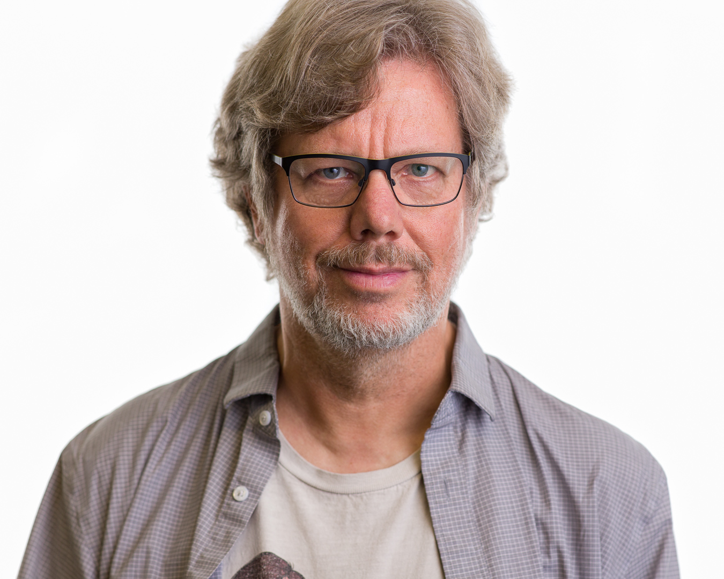

3a. Guido van Rossum - widely known to design python, which has a high level, general purpose programming language (*History of Python*, 2024).

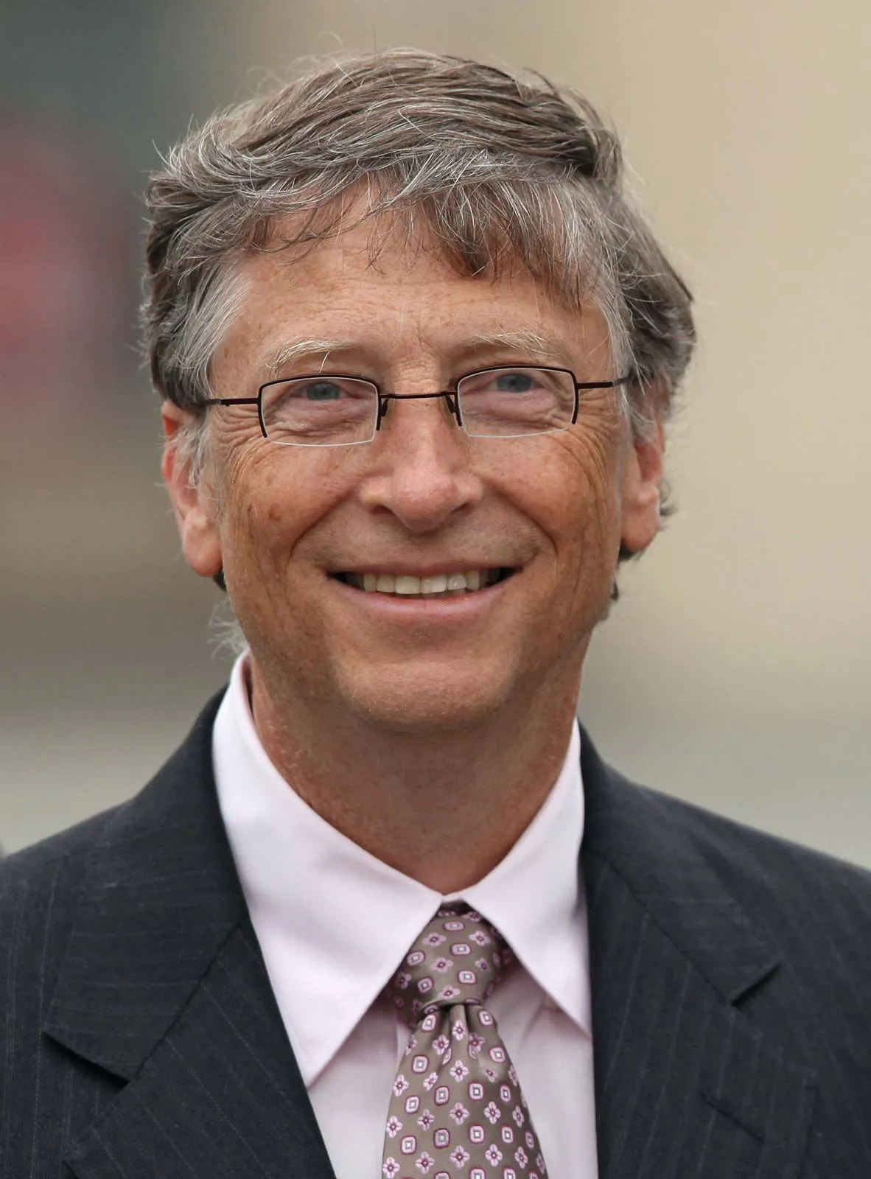

3b. Bill Gates - the co-founder of Microsoft, that developed Windows that is still being used to this day (*Bill Gates Biography*, n.d.)

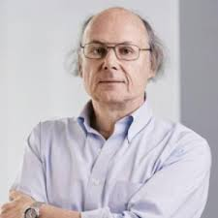

3c. Bjarne Stroustrup - The founder/inventor of C++, which has revolutionized the software industry by enabling programmers to deploy a variety of software techniques

at scale (Fellow, 2015)



3d. Tim Berners-Lee - the inventor of the world wide web and also has written three fundamental technologies that are foundational for the web, HTML, HTTP, and URI.

He created the first ever website editor/browser and first web server (History of the Web, n.d.).

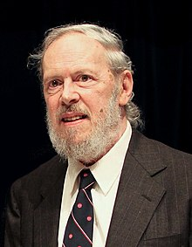

3e. Dennis Ritchie - Creator of UNIX operating system and the C Programming language. Today, the UNIX operating system is the foundation of the world's computing software

while the C programming language is still widely used (Inductee Dennis Ritchie, Who Invented Unix, Transformed Technology, n.d.).

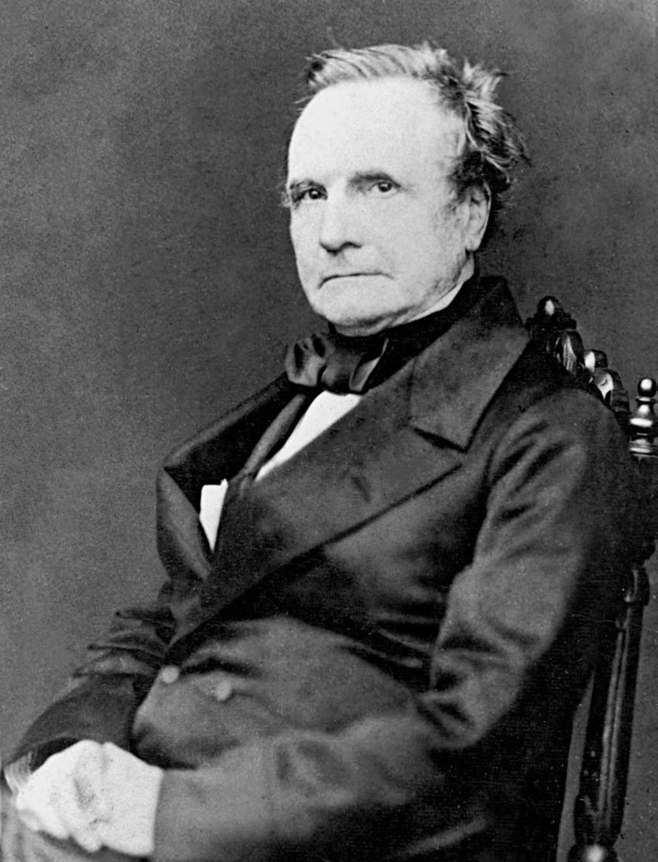

Hardware Developers

3f. Charles Babbage - Known to be the "Father of Computing", made the Difference Engine No.1, the first automatic calculator that was successful (Who was Charles Babbage, n.d.).

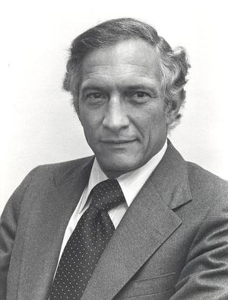

3g. Robert Noyce - Has the nickname of "Mayor of Silicon Valley", co-founded Intel and Fairchild Semiconductor, helped create Intel's first microchip (Robert N. Noyce, n.d.).

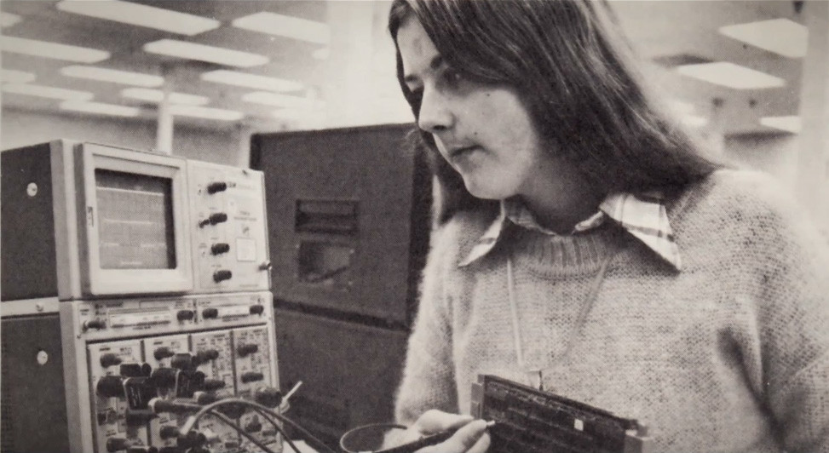

3h. Patty McHugh - Designer of the first motherboard called the Planar Breadboard. They are also now being used in different devices such as mobile phones and etc. not just computers

(History Of The Computer Motherboard, 2024).

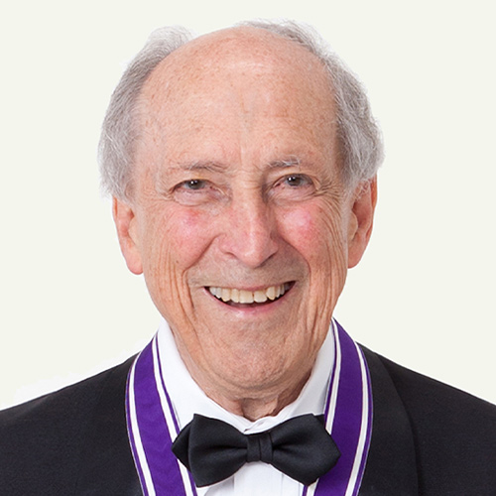

3i. Robert Dennard - Invented the DRAM, which is still being used as the industry standard in these times, enabled the microcomputer revolution (Robert H. Dennard, n.d.).

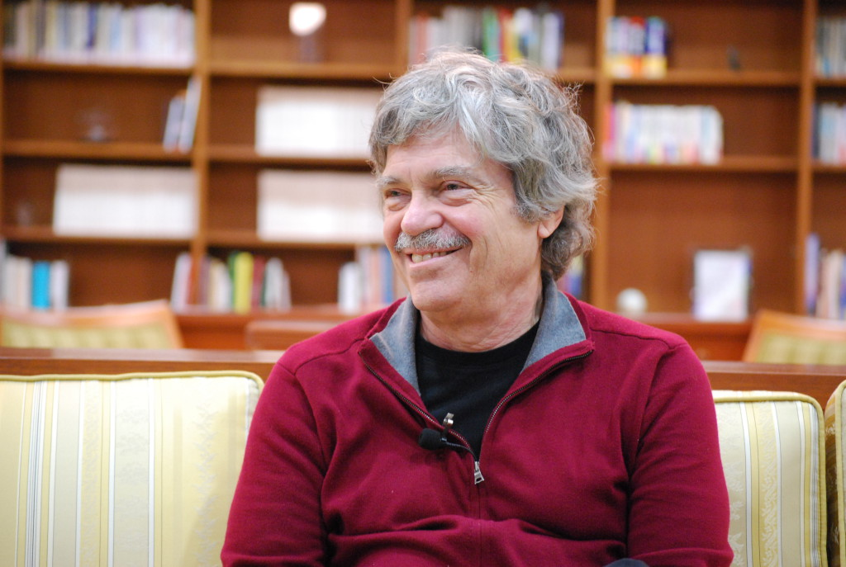

3j. Alan Kay - Designer of the concept of a portable computer. It also became the basis for laptops, tablets, and other portable devices. (Who Invented the Laptop, n.d.).

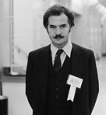

3k. Adam Osborne - The creator of the first laptop and wrote the book "An Introduction to Microcomputers" (Allen, 2020).

4. Cite your reference/s (APA/IEEE)

*Computer basics: basic parts of a computer*. (n.d.). GCFGlobal.org. https://edu.gcfglobal.org/en/computerbasics/basic-parts-of-a-computer/1/

*History of Python.* (2024) GeeksforGeeks. <https://www.geeksforgeeks.org/history-of-python/>

*Bill Gates Biography.* (n.d.) Entrepreneur. <https://www.entrepreneur.com/growing-a-business/bill-gates-biography/197526>

Fellow. (2015) *Bjarne Stroustrup.* Computer History Museum. https://computerhistory.org/profile/bjarne-stroustrup/

*History of the Web.* (n.d.) World Wide Web Foundation. <https://webfoundation.org/about/vision/history-of-the-web/>

*Inductee Dennis Ritchie, Who Invented Unix, Transformed Technology.* (n.d.) National Inventors Hall of Fame. <https://www.invent.org/inductees/dennis-ritchie>

*Who was Charles Babbage* (n.d.) University of Minnesota. <https://cse.umn.edu/cbi/who-was-charles-babbage>

*Robert N. Noyce* (n.d.) IEEE Computer Society. <https://www.computer.org/profiles/robert-noyce>

*History Of The Computer Motherboard.* (2024) Digital Class. <https://www.digitalclassworld.com/blog/history-of-motherboard/>

*Robert H. Dennard* (n.d.) National Inventors Hall of Fame. <https://www.invent.org/inductees/robert-h-dennard>

*Who Invented the Laptop* (n.d.) Javatpoint. <https://www.javatpoint.com/who-invented-laptop>

Scott Allen. (2020) *Adam Osborne: Innovator of the First Portable Computer.* Liveabout. <https://www.liveabout.com/adam-osbourne-biography-1200940>